Practical 18 :

Code :

class Salary1{

    float s = 3100;

}

class Salary2 extends Salary1{

    float s2 = 2100;

}

class Salary3 extends Salary2{

    float s3=1100;

}

public class  Multilevel extends Salary1{

    public static void main(String[] args) {

        Salary3 m = new Salary3();

        System.out.println("The salary of parant is :"+m.s);

        System.out.println("The salary of Child1 is :"+m.s2);

        System.out.println("The salary of Child2 is :"+m.s3);

    }

}

Output :

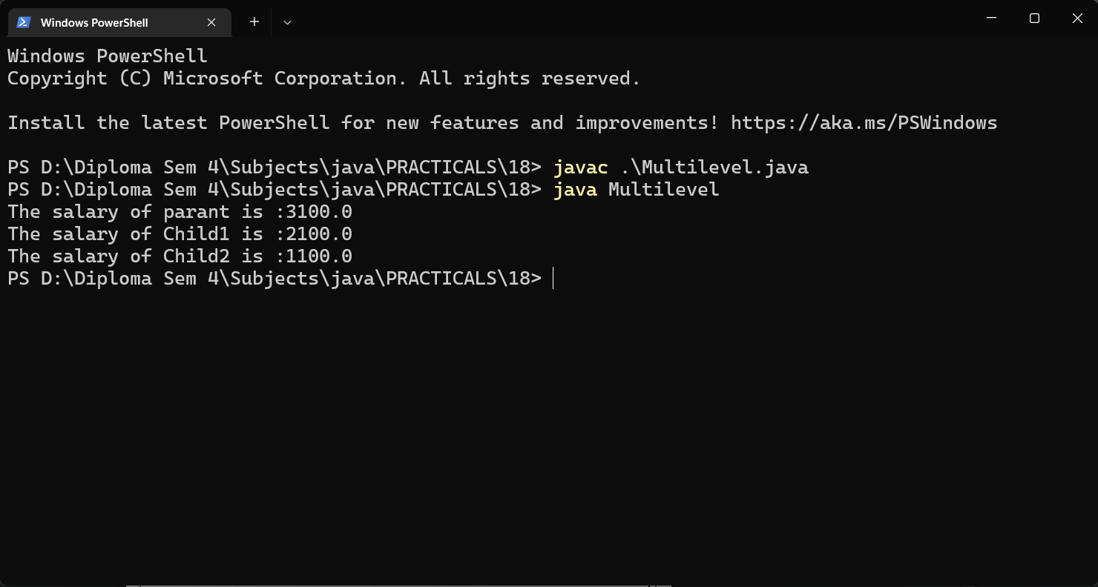

Code :

import java.util.Scanner;

class Area{

    float area(Float a , Float b){

        return a\*b;

    }

}

class Volume extends Area  {

    float volume(Float a,Float b, Float c){

        return a\*b\*c;

    }

}

public class Rooom {

    public static void main(String[] args) {

        Volume v = new Volume();

        Scanner sc = new Scanner(System.in);

        System.out.print("Enter the length of Room :");

        float l = sc.nextInt();

        System.out.print("Enter the Width of Room :");

        float w = sc.nextInt();

        System.out.print("Enter the Height of Room :");

        float h= sc.nextInt();

        System.out.println("The area of Room is :"+v.area(l, w));

        System.out.println("The Volume of Room is :"+v.volume(l, w,h));

        sc.close();

    }

}

Output :

